16th October 2025

RE: Freedom of Information, Oxford Direct Services – Reference: FOI2025/00058

Further to our acknowledgement, I can respond to your Freedom of Information Act 2000 request received on as follows:

Your Request:

Please could you share the below data in relation to your council-owned car parks which are within a 1 mile radius of the Oxford Victorian Christmas Market:
1. The name of the 3 x closest car parks within the vicinity - names and locations
2. Car park charges for December 2024 (historic) for each car park - from 1 hour, up to 24 hour rate.
3. Car park charges for December 2025 (forecast) for each car park - from 1 hour, up to 24 hour rate.
* If you are unable to forecast what upcoming December car park charges will be, please provide current day car parking costs.
Please can this data be provided by inclusion in the body of the email (not redirects/links to the website)?

Our Response:

1. The name of the 3 x closest car parks within the vicinity - names and locations

Worcester Street OX1 2BQ
Gloucester Green OX1 2BN
Oxpens OX1 1RQ

2. Car park charges for December 2024 (historic) for each car park - from 1 hour, up to 24 hour rate.

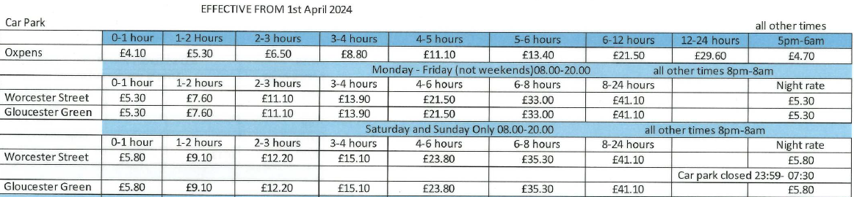
3. Car park charges for December 2025 (forecast) for each car park - from 1 hour, up to 24 hour rate.

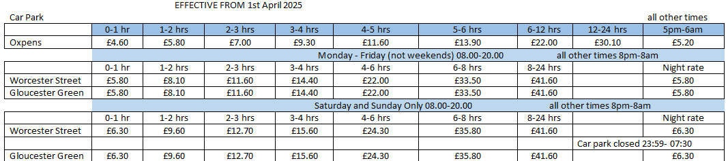

If you disagree with any part of the response to your request, you are entitled to ask Oxford Direct Services for an internal review of the decision(s) made. You may do this by writing to us via FOIreview@odsgroup.co.uk. After the result of the internal review, if you remain dissatisfied, you may ask the Information Commissioner to intervene on your behalf. You may do this by writing to the Information Commissioner's Office, Wycliffe Lane, Wilmslow, Cheshire, SK9 5AF.

Yours sincerely,

Freedom of Information Team

 | Freedom of Information  ODS | Marsh Road Depot, Marsh Road, Oxford, OX4 2HH  freedomofinformation@odsgroup.co.uk | www.odsgroup.co.uk

